

192.168.8.100/24

ADSL Modem

 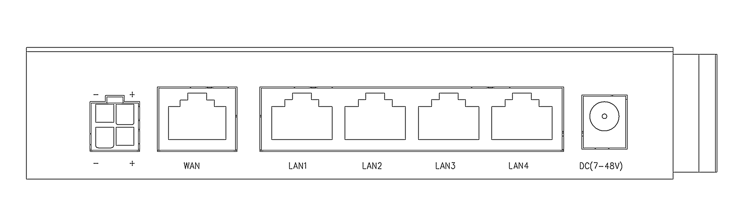

111.221.193.120/32

192.168.8.1/24

111.221.192.1/32

Gateway





111.221.192.1/16

192.168.8.100/24

Gateway



111.221.193.120/16

Router

192.168.8.1/24





10.6.165.1/24

10.6.165.2/24

192.168.8.100/24



192.168.8.1/24

Gateway



192.168.8.100/24



ADSL Modem

Gateway

111.221.193.120/32

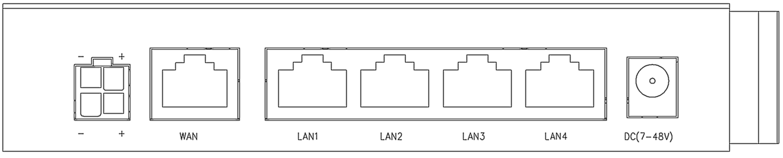

111.221.192.1/32

192.168.8.1/24

Router





192.168.8.100/24

Gateway

192.168.220.60/24



192.168.220.76//24

192.168.8.1/24

192.168.31.120/24



User





Debug

Router

192.168.8.2



Gateway(Repeater Mode)



192.168.8.1

192.168.31.254/24



192.168.31.120/24



User



Debug

192.168.31.254/24



192.168.8.2

Router

Gateway(AP Mode)



192.168.8.1



User



Debug

10.29.16.59/8



192.168.8.2



Gateway(LTE Bridge Mode)



192.168.8.1



192.168.10.1/24

192.168.31.254/24

Router

Router

192.168.8.1/24



**192.168.10.76/24**

**192.168.31.76/24**



192.168.8.101/24

192.168.8.100/24







Gateway(Dual LTE/NR)

**10.67.2.247**

**10.2.9.176**



192.168.8.1/24

192.168.8.100/24



192.168.8.101/24





192.168.31.231

172.16.1.1/24

Internet



**192.168.31.1/24**



**111.221.193.120**



Gateway

**WireGuard Tunnel**



172.16.1.10/24



LTE Gateway

**10.95.3.7**





**192.168.8.1/24**

192.168.8.250





Router

Router



**192.168.10.76/24**

**10.9.213.123**

**10.71.1.74**



**192.168.31.76/24**

Gateway( Mix )

192.168.8.1/24

192.168.8.100/24



192.168.8.101/24





192.168.8.1/24

192.168.1.1/24

192.168.2.1/24

**10.67.2.247**

Gateway



192.168.1.102/24



192.168.8.102/24



192.168.2.102/24



5218-128870





Gateway





192.168.8.1/24

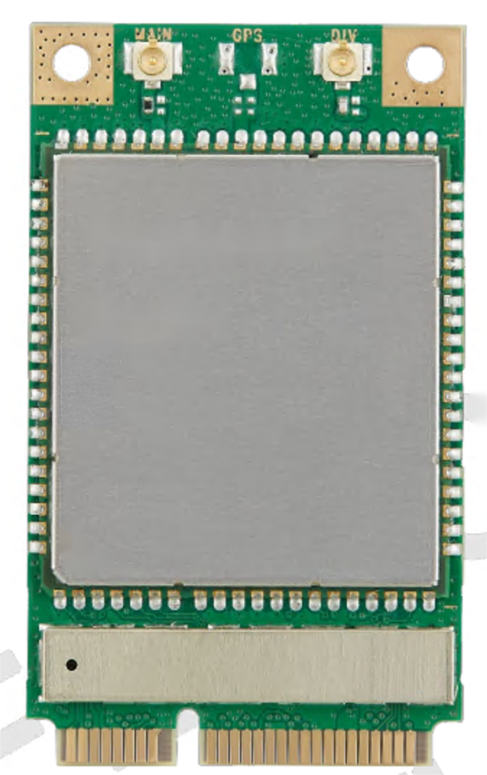

Gateway

192.168.8.251/24

TCP/UDP



AT+CPIN?

+CPIN: READY

OK



Internet

NMEA0183 Format

JSON Format(HTTP)

GPS/BD

MQTT(JSON)

Custom Format

Gateway



192.168.8.1/24

NMEA0183 Format

JSON Format(TCP)



Custom Format

192.168.8.251/24



Internet/VPDN

10.6.165.254/24





10.6.165.2:8080

10.6.165.2:502

10.6.165.2/24

Gateway(192.168.8.1/24)



192.168.8.88:80

192.168.8.83:502

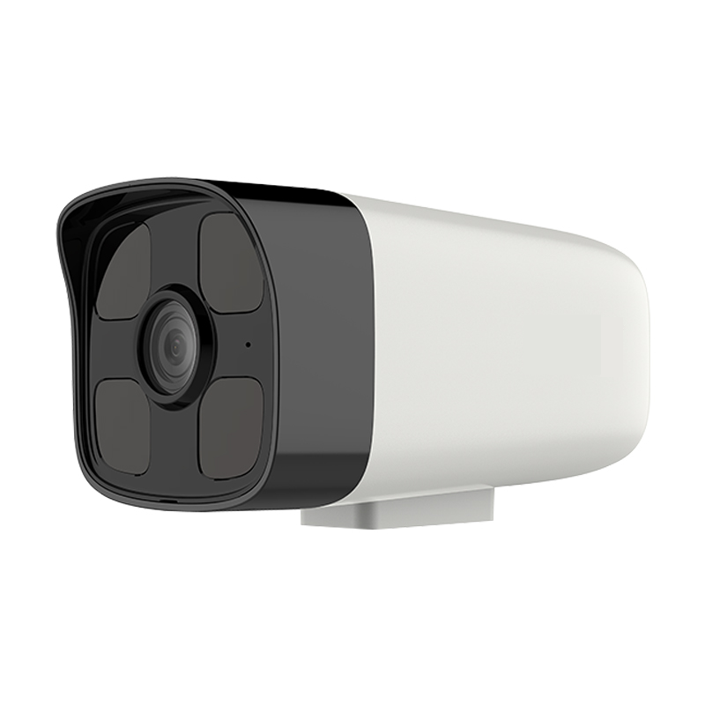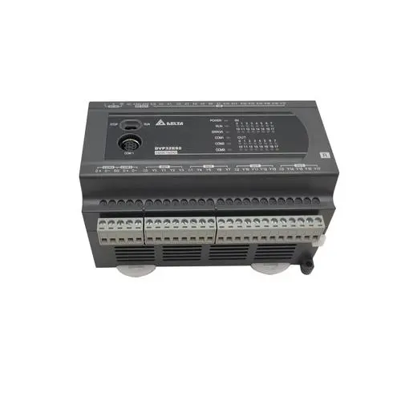

PLC

Camera

192.168.8.83/24

192.168.8.88/24